CSE0001 – Digital Literacy
Task 1 — Digital Literacy Awareness Infographic
Kushagra Singh Rajwar | 25BEC10052 | B.Tech ECE | VIT Bhopal University
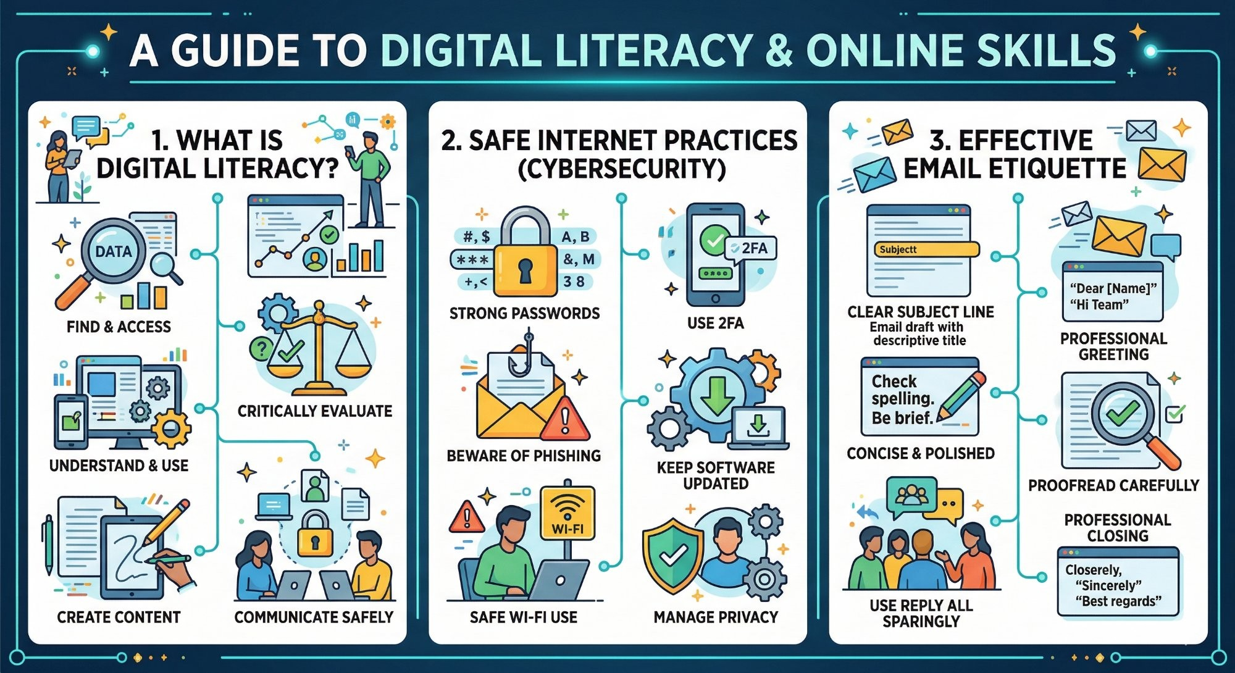
Figure 1: Digital Literacy & Online Skills Infographic — Created using canva tool

Task 1 Write-Up

For Task 1, I created a one-page digital literacy awareness infographic using Canva Tool. The goal was to design a visually engaging resource that helps anyone to understand what it means. The infographic is divided into three clear sections, each covering a key topic from the Digital Literacy course.
The first section, 'What is Digital Literacy?', explains the core components — finding and accessing information, understanding and using digital tools, creating content, critically evaluating sources, and communicating safely online. The second section covers 'Safe Internet Practices (Cybersecurity)', highlighting the importance of strong passwords, enabling two-factor authentication (2FA), being aware of phishing attacks, avoiding unsafe Wi-Fi networks, keeping software updated, and managing personal privacy online. The third section focuses on 'Effective Email Etiquette', covering essentials like writing a clear subject line, using a professional greeting, keeping the message concise and polished, proofreading before sending, using 'Reply All' sparingly, and ending with a proper professional closing.
One thing I found particularly interesting while making this was how much information can be communicated through a well-structured visual layout. Arranging three complex topics into a single, clean infographic required careful thought about which points were most essential. The process helped me realise that digital literacy is not just about one skill — it is a combination of awareness, communication, and safety habits working together.

End of Task 1 | CSE0001 – Digital Literacy | VIT Bhopal University

